External Validation Results

Patient Exclusion Summary
Total patients: 200
Excluded due to missing death information: 0
Excluded due to negative OS months (invalid): 25
Excluded due to missing OS months: 0
Included in survival analysis: 175
Excluded from binary model (censored <12 months, outcome unknown): 18
Included in binary models: 157

Summary Table: Age at Diagnosis and OS Months
Variable | Mean | Median | Min | Max | Missing (n) | Missing (%)
age_at_diagnosis | 54.15 | 57.0 | 18.0 | 88.0 | 0 | 0.0
os_months | 19.67 | 12.02 | 0.92 | 93.99 | 0 | 0.0

Gene Mutation Summary Table
Gene | Positive (n) | Positive (%) | Negative (n) | Negative (%) | Missing (n) | Missing (%)
flt3_itd_cat | 2 | 1.14 | 173 | 98.86 | 0 | 0.0
npm1_cat | 6 | 3.43 | 169 | 96.57 | 0 | 0.0
runx1_cat | 4 | 2.29 | 171 | 97.71 | 0 | 0.0
asxl1_cat | 3 | 1.71 | 172 | 98.29 | 0 | 0.0
tp53_cat | 5 | 2.86 | 170 | 97.14 | 0 | 0.0

Sex Summary Table
Sex | Count | Percent
male | 95 | 54.29
female | 80 | 45.71
missing | 0 | 0.0
total | 175 | 100.0

Denovo Category Summary Table
denovo_cat | Count | Percent
yes | 164 | 93.71
no | 11 | 6.29
missing | 0 | 0.0
total | 175 | 100.0

ELN 2017 Classification Summary Table
ELN class | Count | Percent
favorable | 32 | 18.29
intermediate | 113 | 64.57
adverse | 30 | 17.14
missing | 0 | 0.0
total | 175 | 100.0

OS Months by ELN2017 Classification Table
eln2017mode | mean | median | min | max | count
adverse | 13.02 | 11.02 | 1.02 | 39.95 | 30
favorable | 27.02 | 20.48 | 0.92 | 82.0 | 32
intermediate | 19.36 | 12.02 | 0.92 | 93.99 | 113

Chromosome Category Summary Table
chromosome cat | Count | Percent
normal | 119 | 68.0
complex | 56 | 32.0
missing | 0 | 0.0
total | 175 | 100.0

Survival Models Harrell's C-index Comparison and AUROC at 12 months
Model | C-index
Penalized Cox (ElasticNet) | 0.599
Random Survival Forest | 0.66
Gradient Boosted Survival Models | 0.631

Binary Models Performance (AUROCs and Brier scores)
Model | AUROC | Brier
Logistic Regression | 0.662 | 0.237
RandomForest | 0.628 | 0.262
XGBoost | 0.586 | 0.328
MLP | 0.606 | 0.27

1000 Bootstrap Summary: C-index (Cox / RSF / GBM)
Metric | Mean | 95% CI Lower | 95% CI Upper
Cindex_Cox | 0.599 | 0.551 | 0.647
Cindex_RSF | 0.659 | 0.598 | 0.714
Cindex_GBM | 0.63 | 0.571 | 0.685

1000 Bootstrap Summary: AUROC (Logistic / RF / XGB)
Metric | Mean | 95% CI Lower | 95% CI Upper
AUROC_Logistic | 0.662 | 0.572 | 0.746
AUROC_RF | 0.63 | 0.544 | 0.716
AUROC_XGB | 0.589 | 0.496 | 0.674

Time-dependent AUROC for Cox, RSF, GBM survival
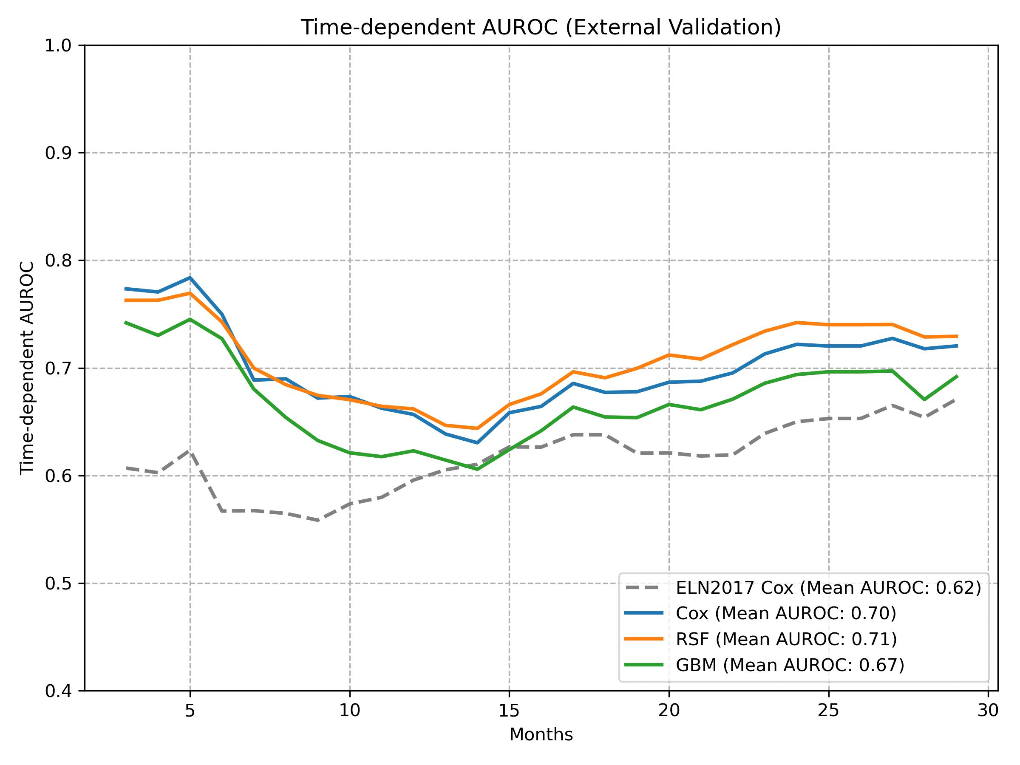

ROC Curves for Binary Models (Logistic Regression, Random Forest, XGBoost, MLP)
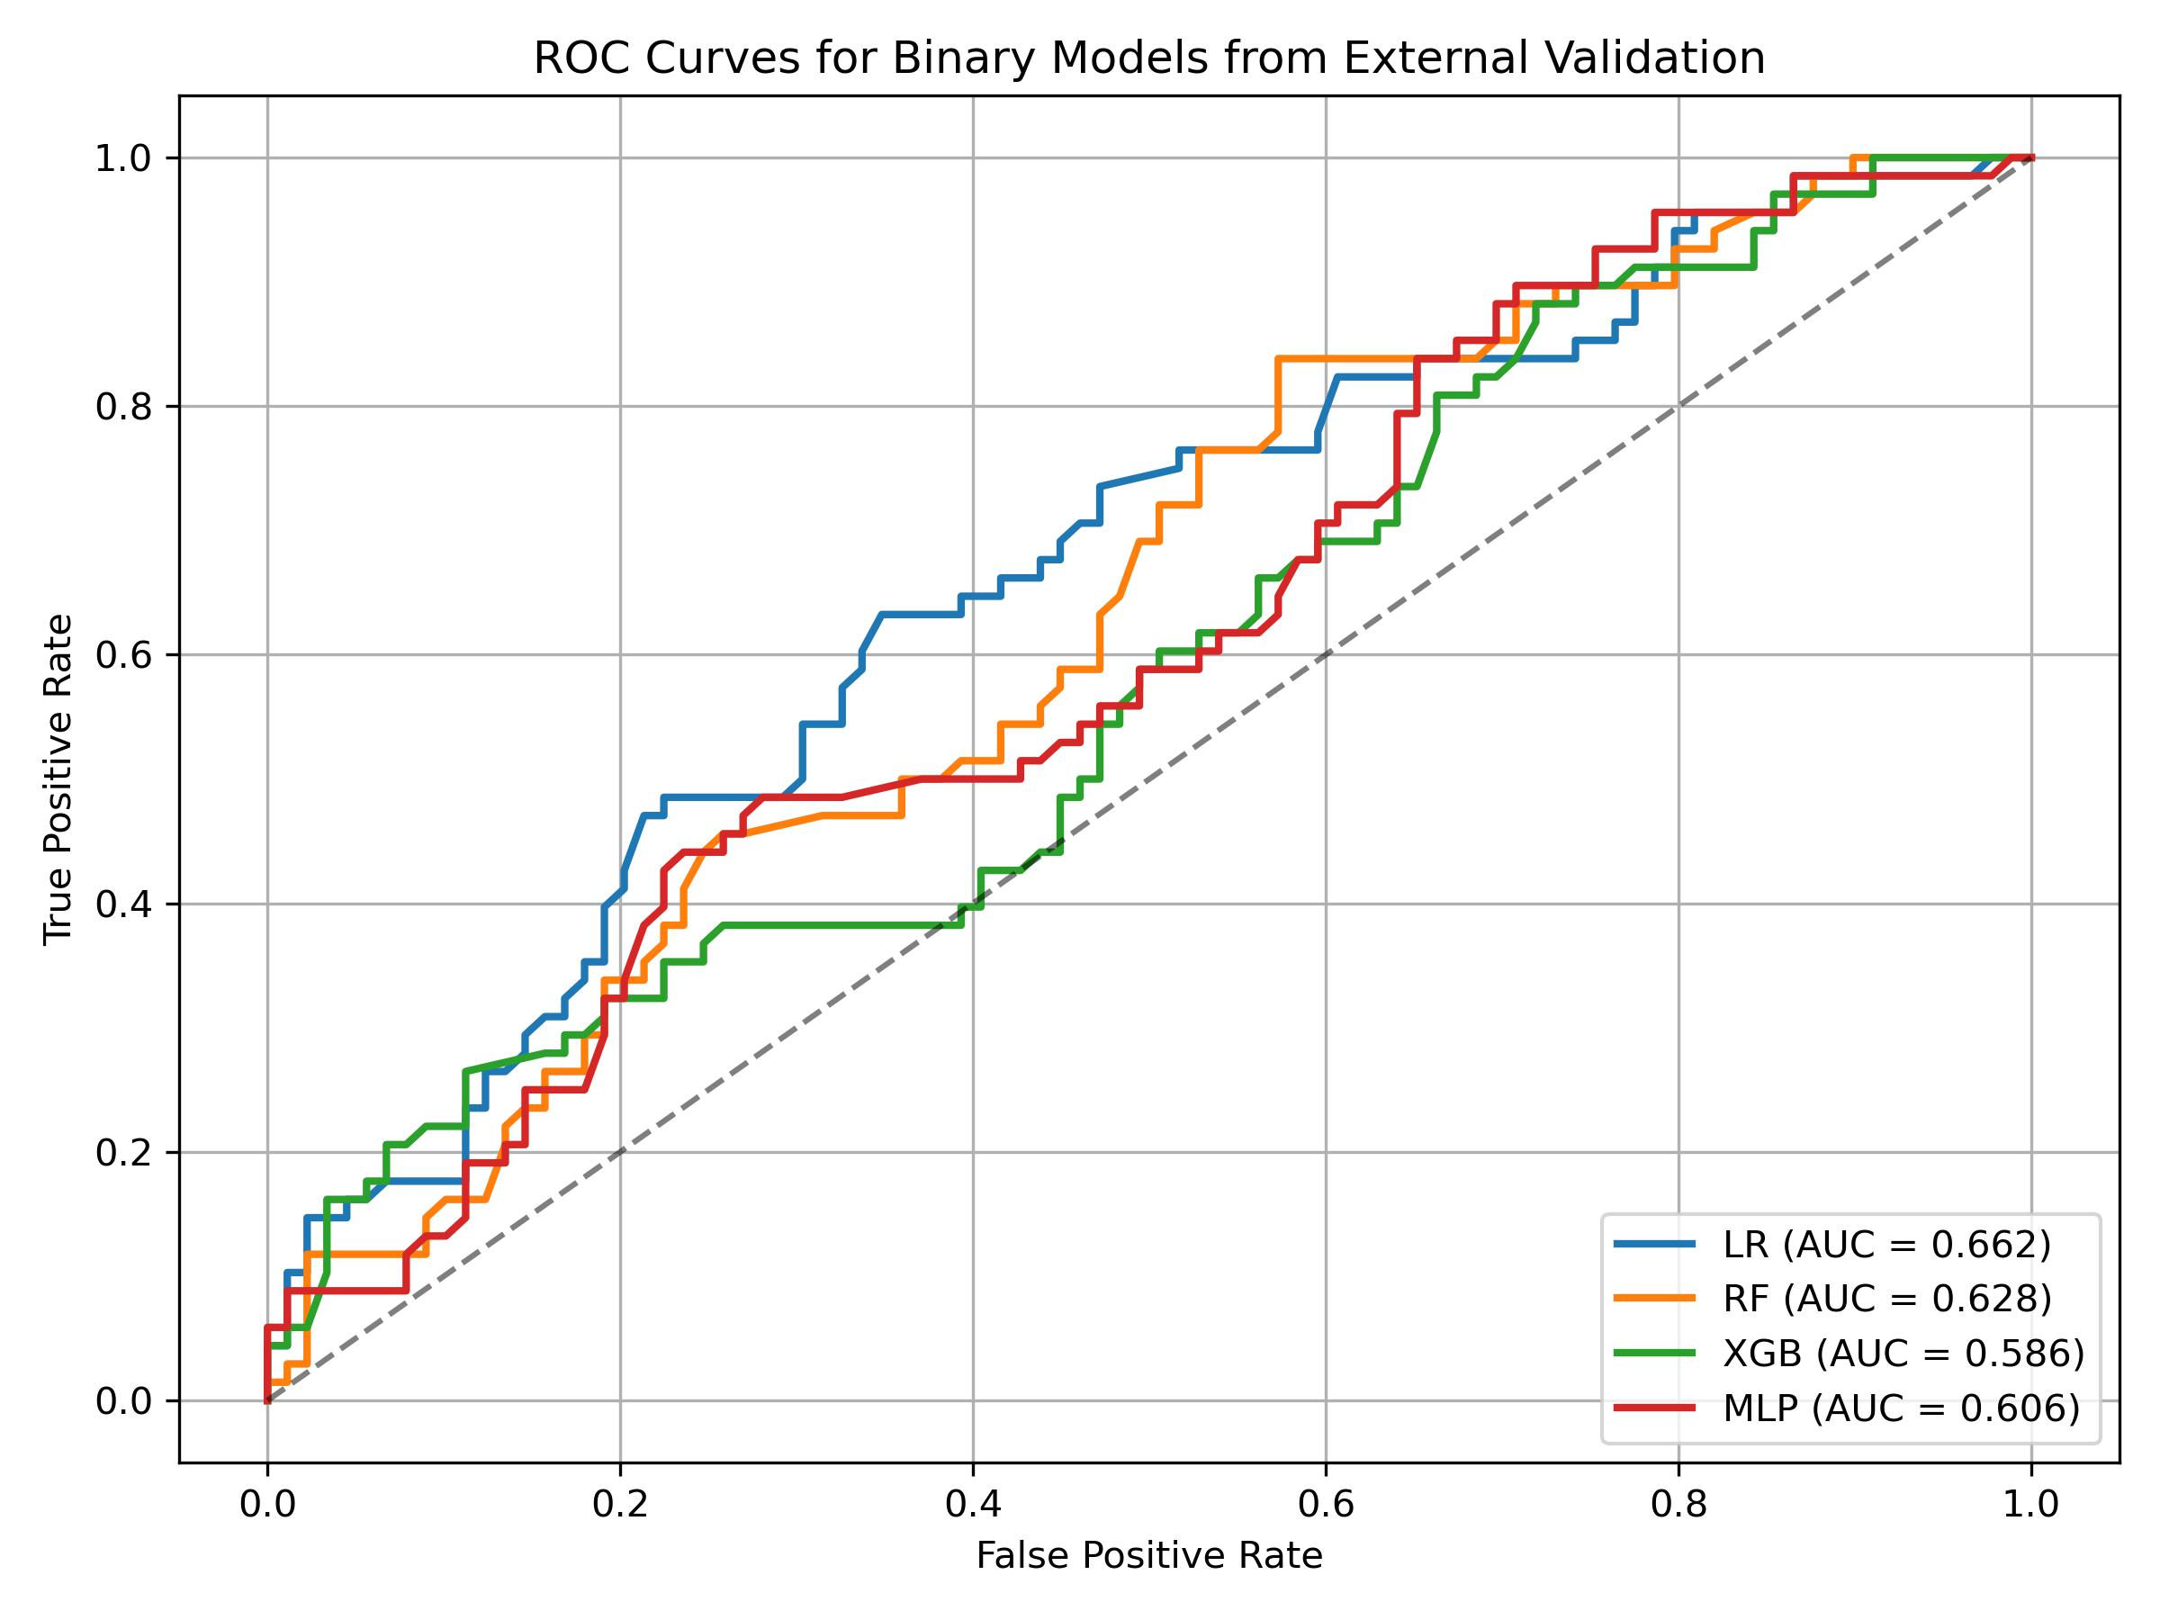

Calibration Plots for Binary Models (Logistic Regression, Random Forest, XGBoost, MLP)
